Errors and their solutions

1. While trying to open a deal slip in CBMB-VMS defect

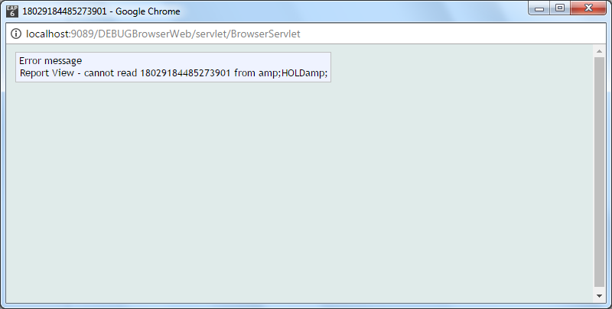

Solution:

Not found  
check for &HOLD& folder in your current directory

If not present create via DBtools  
command for creating CREATE-FILE &HOLD& TYPE=UD

1. CANNOT OPEN F.SPF error in Browserlisten

Solution:

Check your database instance, Is it right or not

You can check your database instance by typing tDiag in you tafj shell